Open PQ Dashboard v1.0

3002002846 (Source Code)

3002002848 (Install Package)

license

Open PQ Dashboard

3002002846 (Source Code)

3002002848 (Install Package)

Software Manual, October, 2015

EPRI Project Manager

T. Cooke

ELECTRIC POWER RESEARCH INSTITUTE  
3420 Hillview Avenue, Palo Alto, California 94304-1338 ▪ PO Box 10412, Palo Alto, California 94303-0813 ▪ USA  
800.313.3774 ▪ 650.855.2121 ▪ askepri@epri.com ▪ www.epri.com

DISCLAIMER OF WARRANTIES AND LIMITATION OF LIABILITIES

Electric Power Research Institute, Inc. (“EPRI”) reserves all rights in the Program as delivered. The Program or any portion thereof may not be reproduced in any form whatsoever except as provided by license, without the consent of EPRI.

A license under EPRI's rights in the Program can be obtained directly from EPRI.

The embodiments of this Program and supporting materials may be independently available from Electric Power Software Center (EPSC) for an appropriate distribution fee.

Electric Power Software Center (EPSC)  
9625 Research Drive  
Charlotte, NC 28262

THIS NOTICE MAY NOT BE REMOVED FROM THE PROGRAM BY ANY USER THEREOF.

NEITHER EPRI, ANY MEMBER OF EPRI, the organization(s) below, NOR ANY PERSON ACTING ON BEHALF OF any of THEM:

1. MAKES ANY WARRANTY OR REPRESENTATION WHATSOEVER, EXPRESS OR IMPLIED, INCLUDING ANY WARRANTY OF MERCHANTABILITY OR FITNESS OF ANY PURPOSE WITH RESPECT TO THE PROGRAM ; OR

2. ASSUMES ANY LIABILITY WHATSOEVER WITH RESPECT TO ANY USE OF THE PROGRAM OR ANY PORTION THEREOF OR WITH RESPECT TO ANY DAMAGES WHICH MAY RESULT FROM SUCH USE.

RESTRICTED RIGHTS LEGEND: USE, DUPLICATION, OR DISCLOSURE BY THE GOVERNMENT IS SUBJECT TO RESTRICTION AS SET FORTH IN PARAGRAPH (g) (3) (i), WITH THE EXCEPTION OF PARAGRAPH (g) (3) (i) (b) (5), OF THE RIGHTS IN TECHNICAL DATA AND COMPUTER SOFTWARE CLAUSE IN FAR 52.227-14, ALTERNATE III.

Reference herein to any specific commercial product, process, or service by its trade name, trademark, manufacturer, or otherwise, does not necessarily constitute or imply its endorsement, recommendation, or favoring by EPRI.

The following organization(s), under contract to EPRI, prepared this report:

Grid Protection Alliance, Inc.

NOTE

For further information about EPRI, call the EPRI Customer Assistance Center at 800.313.3774 or   
e-mail askepri@epri.com.

Electric Power Research Institute, EPRI, and TOGETHER…SHAPING THE FUTURE OF ELECTRICITY are registered service marks of the Electric Power Research Institute, Inc.

Copyright © 2014 Electric Power Research Institute, Inc. All rights reserved.

Acknowledgments

The following organization(s), under contract to the Electric Power Research Institute (EPRI), prepared this report:

Grid Protection Alliance, Inc.   
1206 Broad Street  
Chattanooga, TN 37402

Principal Investigator  
R. Robertson

This report describes research sponsored by EPRI.

Software Description

The Open PQ Dashboard version 1.0 is an open source software (OSS) application developed for EPRI by the Grid Protection Alliance that enables the visualization of findings and insights derived from power quality (PQ) data files. It is assumed that a user will have a basic understanding of PQ data, including the concepts of ‘events’ and ‘trends’, and the measurement quantities typically included in PQ data files.

Description

The Open PQ Dashboard version 1.0 provides visual displays to quickly convey the location of reporting devices and a count of alarms that have occurred at each location in the previous 24 hours. It also provides a summary of the alarm counts for the previous 30 days, and includes detail displays of information about the alarm types, and trends based on hourly summary values. Event details and fault distance calculations, full resolution detail of every recorded trend value, and data quality metrics are also included. This version 1.0 of the software is fully operational and can be tested with the included dataset, but is intended to be deployed in an electric utility and integrated into their PQ data analysis processes. It incorporates new techniques for extracting information from large numbers of PQ data files, and provides navigation and controls that allow a system wide ‘fleet-view’ dashboard display, and drill-down capabilities to explore details of the input datasets including interactive waveform visualization and phasor charts.

The Open PQ Dashboard is a web based application that visualizes data contained in the openXDA database. openXDA is a data analysis platform that ingests event and trending data from standard PQDIF and COMTRADE files and positions it in the database to facilitate responsive controls in the web based Open PQ Dashboard user interface.

Installation and deployment of the Open PQ Dashboard and openXDA require a SQL Server database, an IIS web server, and network connectivity to the input data repository of PQDIF and/or COMTRADE files. This level of complexity requires that the installer have access to these resources with appropriate access credentials, and an understanding of how to manage the resources. A detailed description of prerequisites and system requirements are included in this manual.

Benefits and Value

The Open PQ Dashboard version 1.0 presents information from large numbers of PQ data files gathered from the entire fleet of PQ reporting devices. Benefits of this strategy include unique insights such as:

* A comprehensive view of the entire fleet in either a map or grid display
* A quick view of trouble spots
* The ability to drill down for additional detail where desired
* Statistical control chart alarms for each unique trended data channel
* Input data quality: availability and correctness

The value of these new insights include:

* The ability to react more quickly to PQ issues
* The ability to recognize PQ system failures more quickly
* Better allocation of resources for corrective measures

Platform Requirements

The following items are minimum requirements for successful installation and deployment of the Open PQ Dashboard and openXDA.

Operating System

64-bit Windows 7 or Windows Server 2008 R2 (or later versions)

Software

* .NET 3.5 SP1 (required by SQL Server 2012)
* .NET 4.5 (required by Open PQ Dashboard)
* SQL Server 2012 with management tools (free Express version is fine)
* IIS web server
* Highcharts v4.0.4 or newer
* jQWidgets 3.6.0 or newer

Keywords

Power quality, dashboard, data quality, open source

Contents

*1* installation Instructions 9

*2* Prerequisites 9

*3* Installing .NET 4.5 10

*4* Installing openhistorian 2.0 11

*5* Installing openxda 11

Run openXDASetup 12

End-User License Agreement 13

Custom Setup 14

Database Connection 15

Ready to install openXDA 16

User Account Control 17

Installing openXDA Progress 18

Setup Finish 19

*6* installating open pq dashboard 20

*7* Load System configuration 28

*8* Load test data 33

Included Test Data 38

*9* User and dashboard configuration 39

*10* operating open pq dashboard 52

Components of the Visual Display 52

Context Control Bar Elements 53

Top row elements 53

Second row elements 53

Fleet View Panel 54

Overview Panel 56

Detail Panel 56

Events by line for a selected site 57

Waveform display for an event 57

List of Figures

Figure 1. openHistorian Setup: Set up primary historian 11

Figure 2. openXDA Setup: initial screen 12

Figure 3. openXDA Setup: end-user license agreement 13

Figure 4. openXDA Setup: custom setup screen 14

Figure 5. openXDA Setup: database connection 15

Figure 6. openXDA Setup: ready to install screen 16

Figure 7. openXDA Setup: installation progress 18

Figure 8. openXDA Setup: installation completed screen 19

Figure 9. Copying Device Definitions File 28

Figure 10. Paste Device Definitions File in openXDA installation folder 29

Figure 11. If prompted for administrator permissions press Continue 30

Figure 12. Open ldconfig.bat file 31

Figure 13. ldconfig.bat loading system configuration file 32

Figure 14. Open openXDA console to monitor service operation 33

Figure 15. openXDA console display 34

Figure 16. Copy Test Data 35

Figure 17. Past Test Data to Watch Folder 36

Figure 18. If prompted for administrator permissions press continue 37

Figure 19. openXDA console display of service messages 38

Figure 20. Dashadmin Home Page 39

Figure 21. Manage Groups 40

Figure 22. Group Configuration 41

Figure 23. Enter name, select active, click Insert 42

Figure 24. Edit 'All Meters' group 43

Figure 25. Available Meters 44

Figure 26. Move available meters to authorized meters list, and click update 45

Figure 27. Manage Users 46

Figure 28. Enter your Windows user name, check active, click insert 47

Figure 29. Click Edit to authorize groups 48

Figure 30. Available groups 49

Figure 31. Move available groups to authorized groups, click update 50

Figure 32. Click dashboard settings 51

Figure 33. Open PQ Dashboard: visual display components 52

Figure 34. Fleet view panel example map display 54

Figure 35. Fleet view panel example grid display 55

Figure 36. Overview panel example display 56

Figure 37. Detail panel example display 56

Figure 38. Example display of events by line for a site 57

Figure 39. Example display of waveform viewer 57

# installation Instructions

Installation of EPRI Software at Client Site

EPRI develops software using a number of third party software products and tools that run on various operating systems and server platforms. Reports from the software industry suggest there are known security issues with some products and systems. EPRI recommends that, if you are using EPRI software, you review its use with your Information Technology (IT) department and their overall strategy to ensure that all recommended security updates and patches are installed as needed in your corporation. If you have any concerns please call the EPRI Customer Assistance Center (CAC) at 1-800-313-3774 (or email [askepri@epri.com](mailto:askepri@epri.com)).

If you experience difficulties accessing the application

If you experience difficulties accessing the application after standard installation on a system with 64-bit Windows 7 or Windows Server 2008 R2, please consult your IT department personnel to have proper access permissions setup for your use. If the problem cannot be resolved, please call the EPRI Customer Assistance Center (CAC) at 1-800-313-3774 (or email [askepri@epri.com](mailto:askepri@epri.com)).

The following sections explain the necessary steps to install and use the software

This manual assumes that the prerequisite software including the operating system (64-bit Windows 7 or Windows Server 2008 R2), a SQL Server, .NET, an IIS web server, Highcharts, and jQWidgets have been previously installed, and describes the steps necessary to install the openXDA database and the Open PQ Dashboard web application so that the Open PQ Dashboard will execute correctly. It then presents the steps to run the application.

# Prerequisites

The following hardware and software items are required before the Open PQ Dashboard and openXDA can be successfully installed. The operating system, database server, and web server are assumed to be standard IT infrastructure and are not addressed in this document. The .NET framework, Highcharts, and jQWidgets are commercially available third party software packages. If a prerequisite software element is already installed, the respective section of this document can be skipped.

Note: The openXDA service and PQ Dashboard both require mixed mode authentication to be enabled on the SQL Server instance where the openXDA database is installed. This setting can be selected during SQL Server installation and is turned off by default. If your instance is configured to allow only Windows authenticated users or if you are unsure whether mixed mode authentication is enabled, refer to the following link for instructions on how to modify the setting: <https://msdn.microsoft.com/en-us/library/ms188670.aspx>.

Also note, the default configuration of IIS does not include the ASP.NET 4.5 or Windows Authentication features which are both required by the PQ Dashboard. These features should be enabled before attempting to install the PQ Dashboard.

* 1. **Operating System**

64-bit Windows 7 or Windows Server 2008 R2 (or later versions)

**Minimum Hardware**

* 2.0 GHz processor
* 2.0 GB of memory
* 50 GB of available disk space for installation and testing
* Operational disk space requirements will be proportional to the volume of input data

**Software**

* .NET 3.5 SP1 (required by SQL Server 2012)
* .NET 4.5 (required by Open PQ Dashboard)
* SQL Server 2012 with management tools (free Express version is fine)
* IIS web server
  + ASP.NET 4.5
  + Windows Authentication
* Highcharts v4.0.4 or newer
* jQWidgets 3.6.0 or newer
* openHistorian 2.0

**Compatible Browsers**

* Internet Explorer 9 or newer
* Google Chrome
* Mozilla Firefox

# Installing .NET 4.5

Note: If .NET 4.5 is installed, please go to INSTALLING OPENHISTORIAN 2.0.

Download the .NET 4.5 installer from the following location:

<http://www.microsoft.com/en-us/download/details.aspx?id=30653>

Install this version of .NET before continuing to other installation steps.

# Installing openhistorian 2.0

Note: If openHistorian 2.0 is installed, please go to INSTALLING OPENXDA.

Download the openHistorian 2.0 from the following location:

<http://www.gridprotectionalliance.org/NightlyBuilds/openHistorian/Beta/openHistorian.Installs.zip>

Extract the downloaded archive and run Setup.exe to begin the installation. Follow the installation steps until you reach the following step. Enter the information as shown in the screenshot.

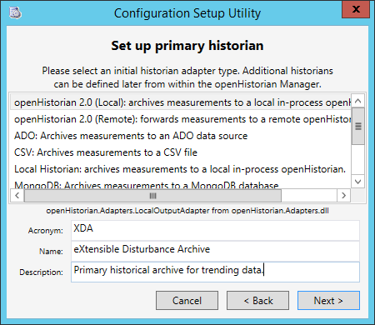

Figure . openHistorian Setup: Set up primary historian

After entering the information as shown above, follow the rest of the installation steps to completion. Finish installing openHistorian 2.0 before continuing to other sections of this manual.

# Installing openxda

EXPLAIN WHERE TO GET THE INSTALLER>>>>

## Run openXDASetup

The following screen will appear, click Next to install.

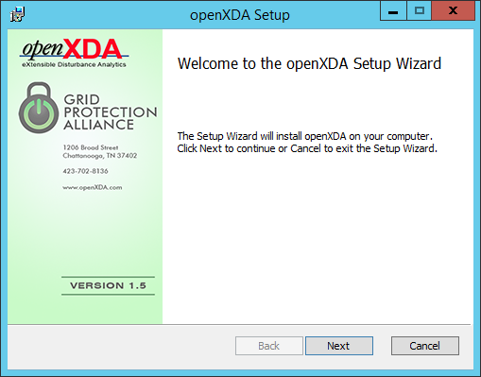

Figure . openXDA Setup: initial screen

## End-User License Agreement

Click the check box to accept the MIT License terms then click Next to continue, or Cancel to exit the installation.

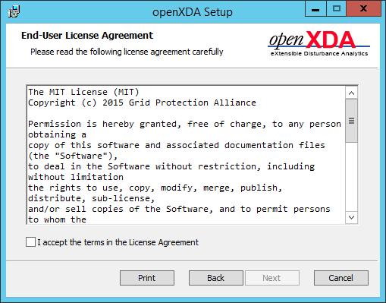

Figure . openXDA Setup: end-user license agreement

## Custom Setup

For a new installation all components should be installed as shown in the screen below. If a different installation location is desired click the Browse button and select the location. When any changes to the setup screen are complete click Next.

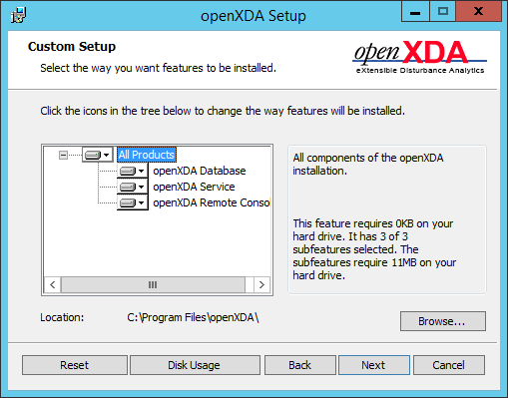

Figure . openXDA Setup: custom setup screen

## Database Connection

For a new installation the default values are recommended but may be changed as specified by your database administrator. When the database connection is specified as desired click Next.



Figure . openXDA Setup: database connection

## Ready to install openXDA

When you are ready to install openXDA click the Install button.

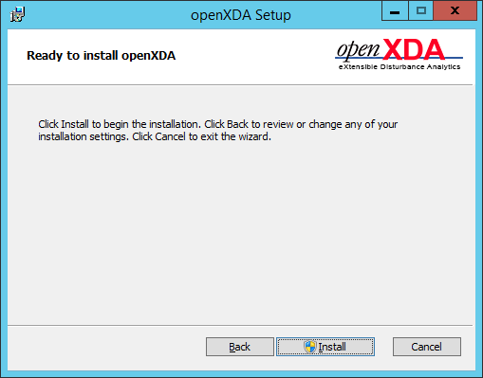

Figure . openXDA Setup: ready to install screen

## User Account Control

If you want the openXDA setup to install openXDA on your computer click the Yes button, if not click No to cancel the installation.

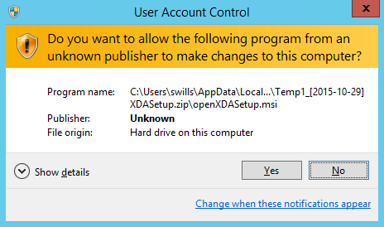

## Installing openXDA Progress

Installation progress will be indicated in the screen below. Click next when the install is complete.

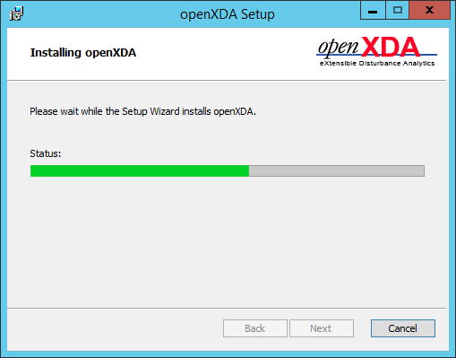

Figure . openXDA Setup: installation progress

## Setup Finish

When the screen below is displayed to indicate that openXDA Setup has completed click the Finish button to dismiss the screen.

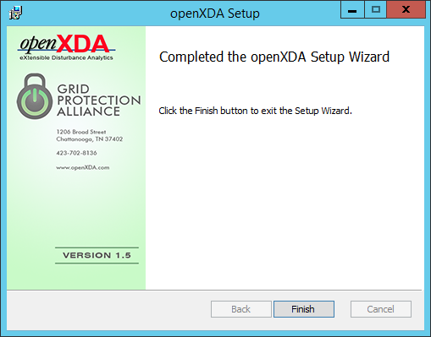

Figure . openXDA Setup: installation completed screen

# installating open pq dashboard

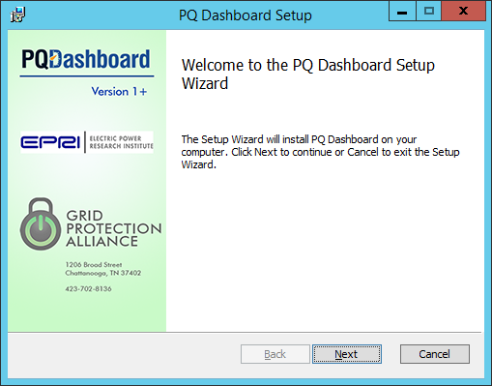

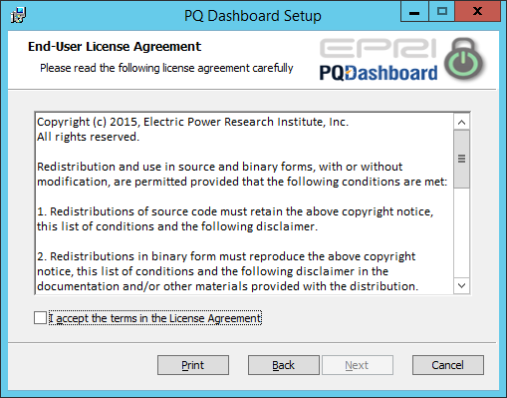

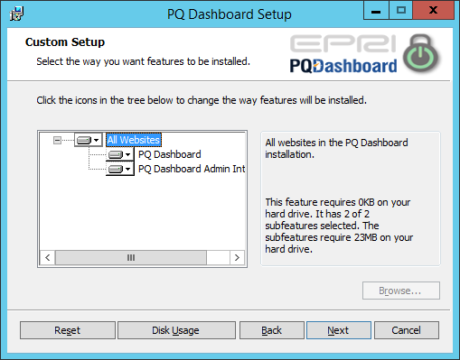

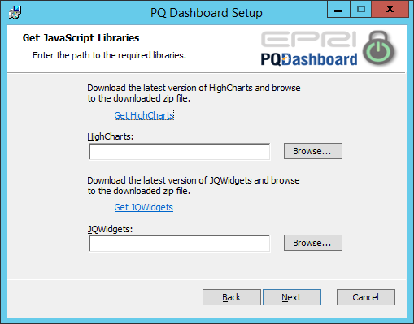

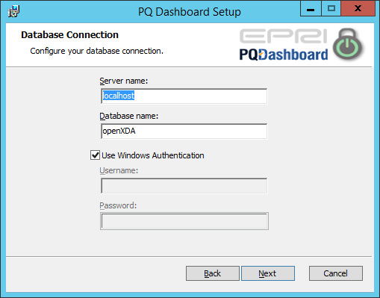

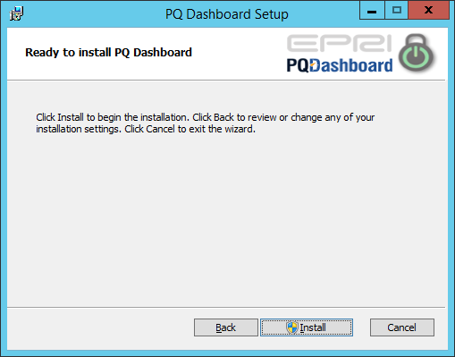

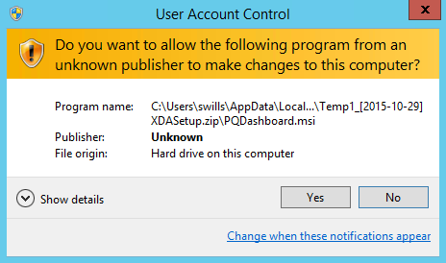

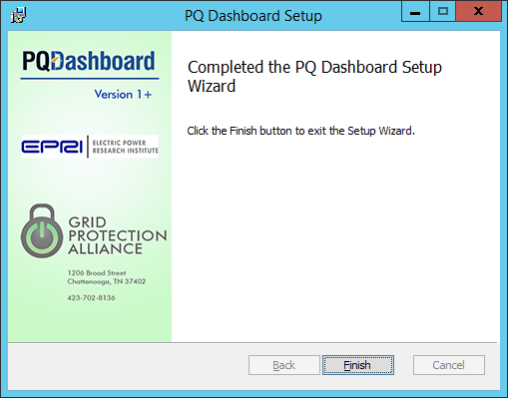

# Load System configuration

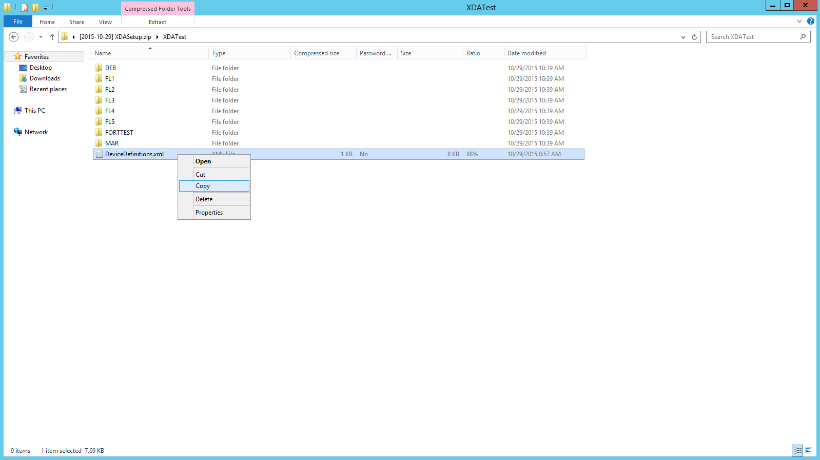

Figure . Copying Device Definitions File

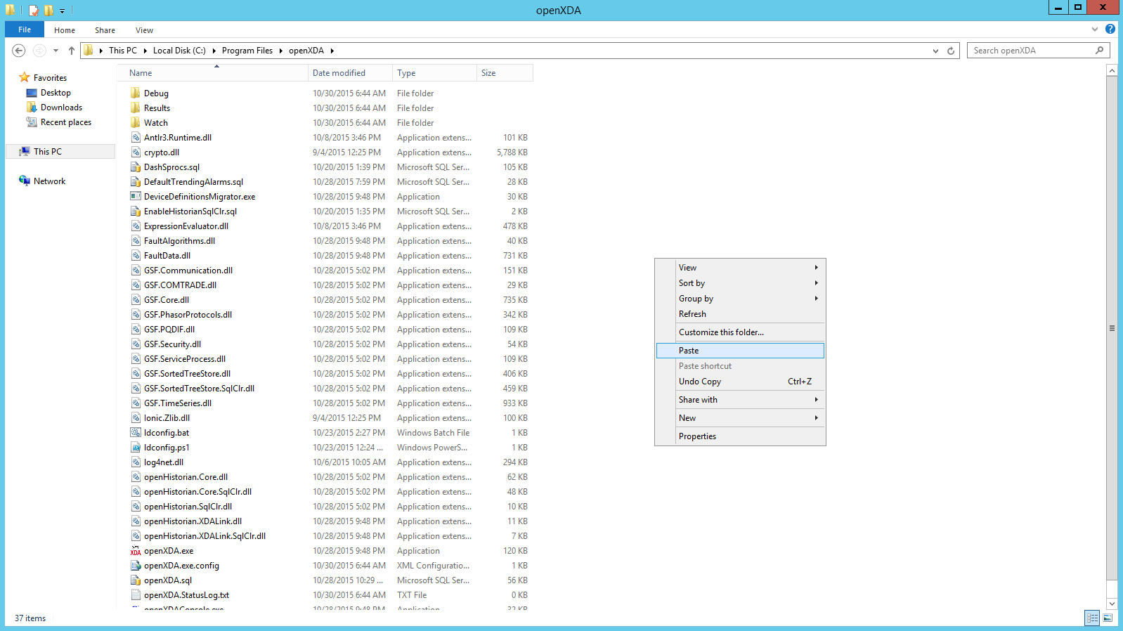

Figure . Paste Device Definitions File in openXDA installation folder

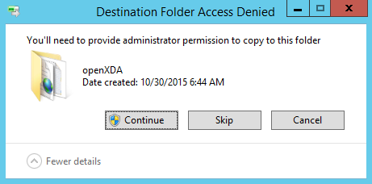

Figure . If prompted for administrator permissions press Continue

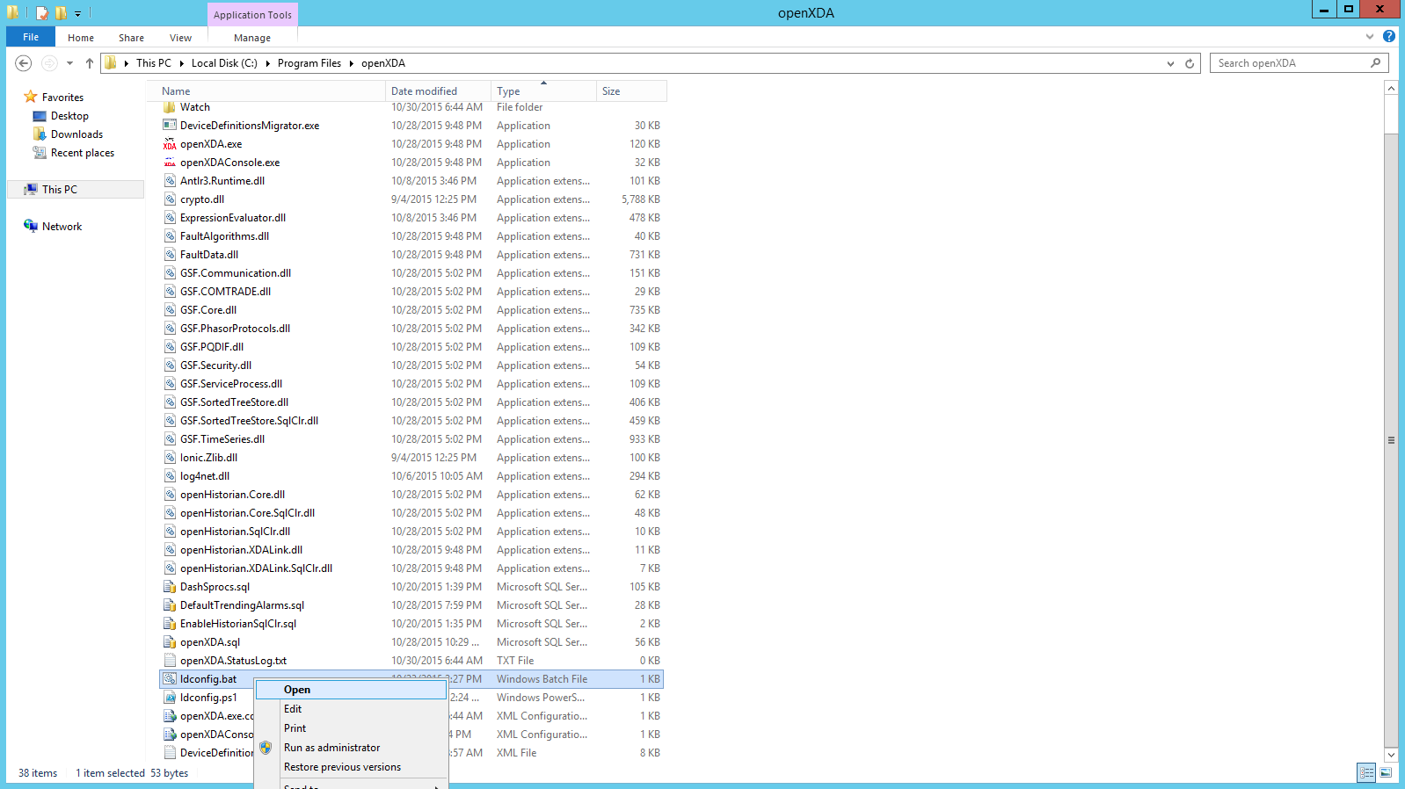

Figure . Open ldconfig.bat file

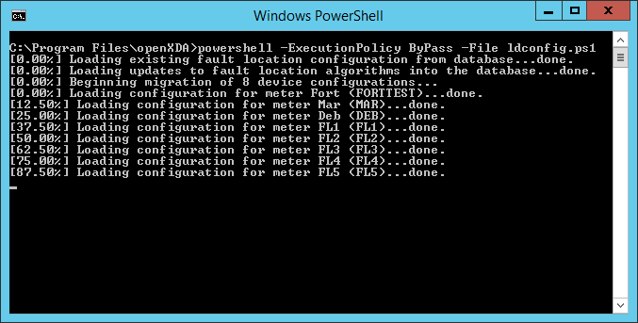

Figure . ldconfig.bat loading system configuration file

# Load test data

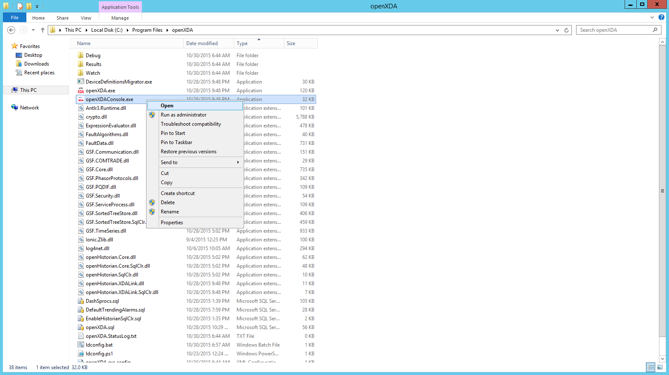

Figure . Open openXDA console to monitor service operation

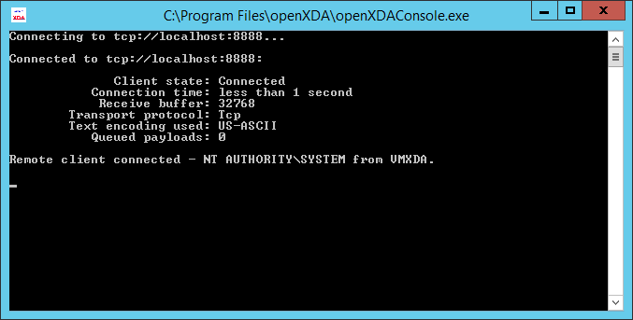

Figure . openXDA console display

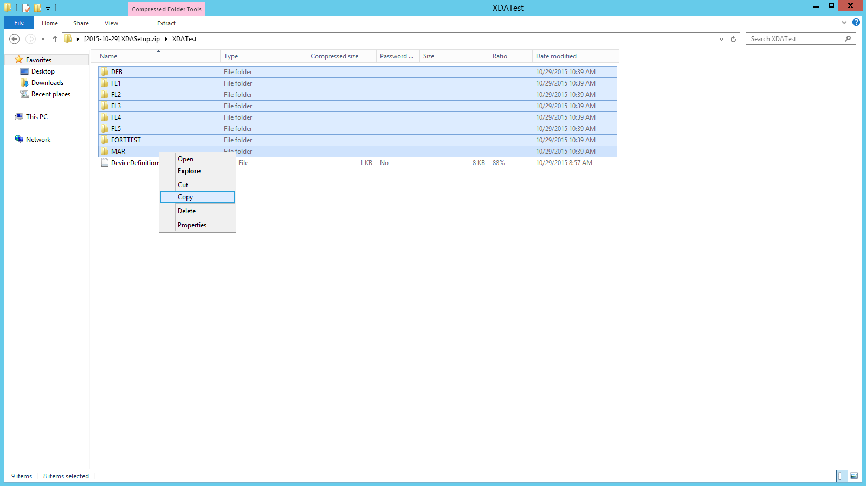

Figure . Copy Test Data

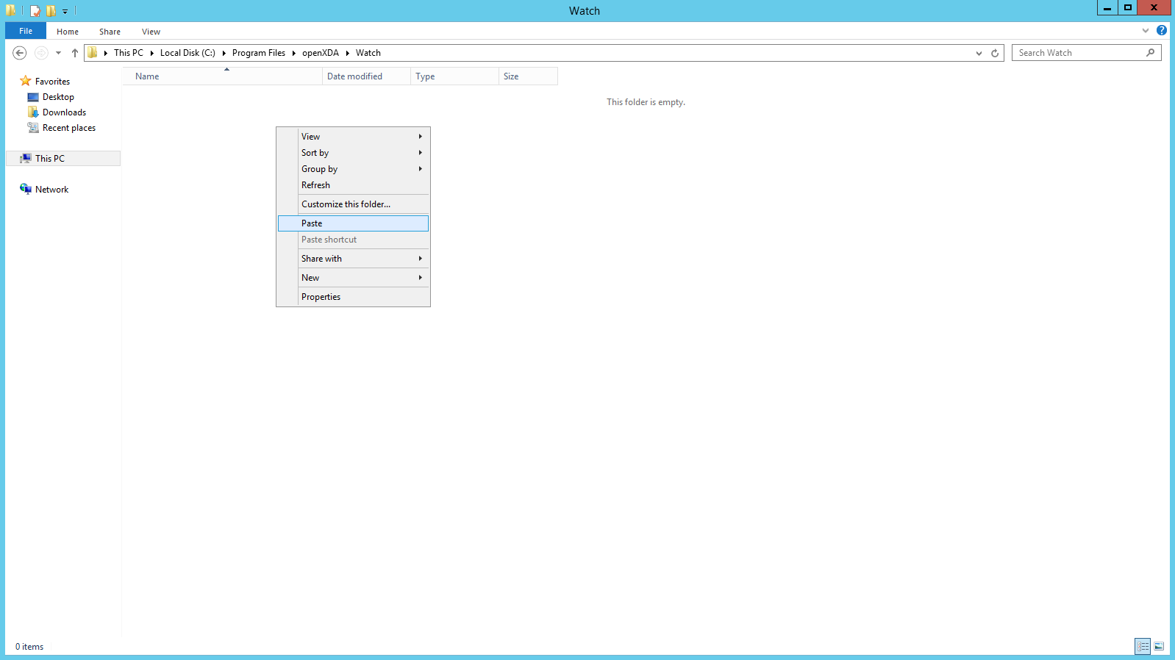

Figure . Past Test Data to Watch Folder

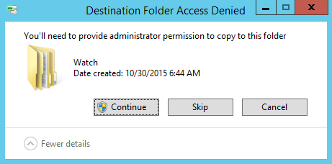

Figure . If prompted for administrator permissions press continue

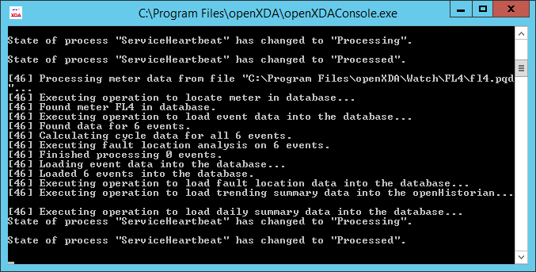

Figure . openXDA console display of service messages

## Included Test Data

The test dataset contains data for 8 sites with data available for exercising all tabs. Dates from 12/29/2013 through 01/08/2014 should be used for all tabs except faults. Data to exercise the fault tab is on 09/03/2014.

# User and dashboard configuration

## Locate the PQ Dashboard Administration icon in your programs list,



or navigate to <http://localhost/dashadmin/>

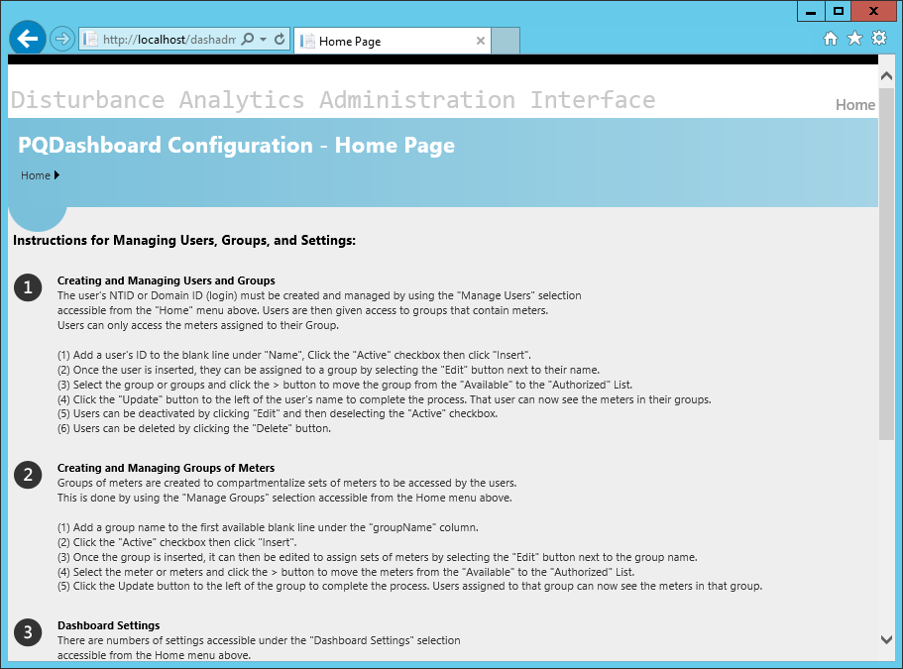

Figure . Dashadmin Home Page

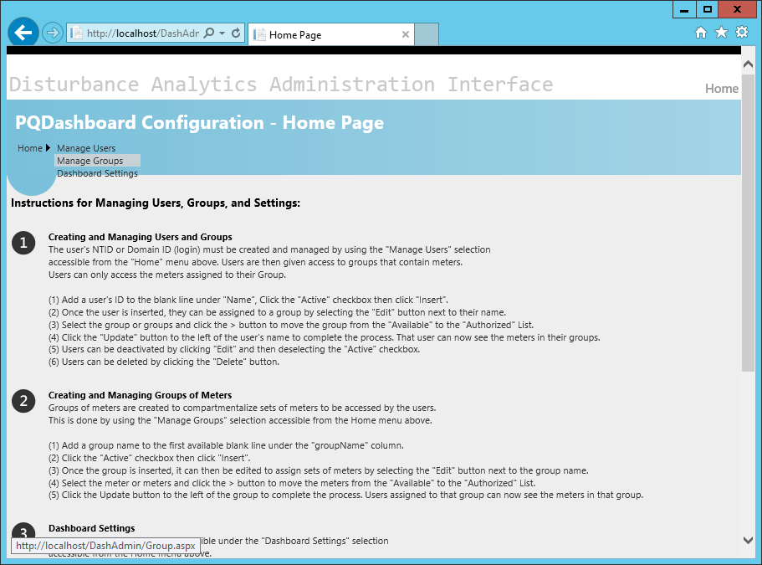

Figure . Manage Groups

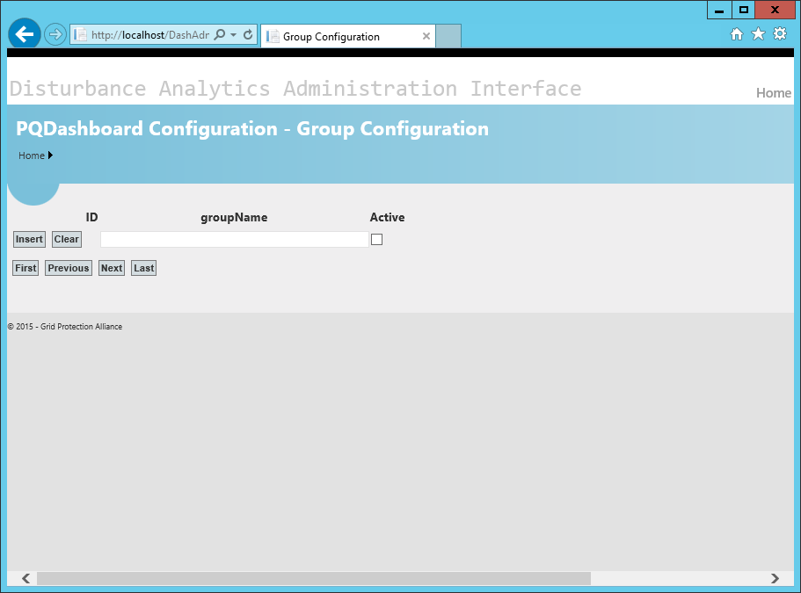

Figure . Group Configuration

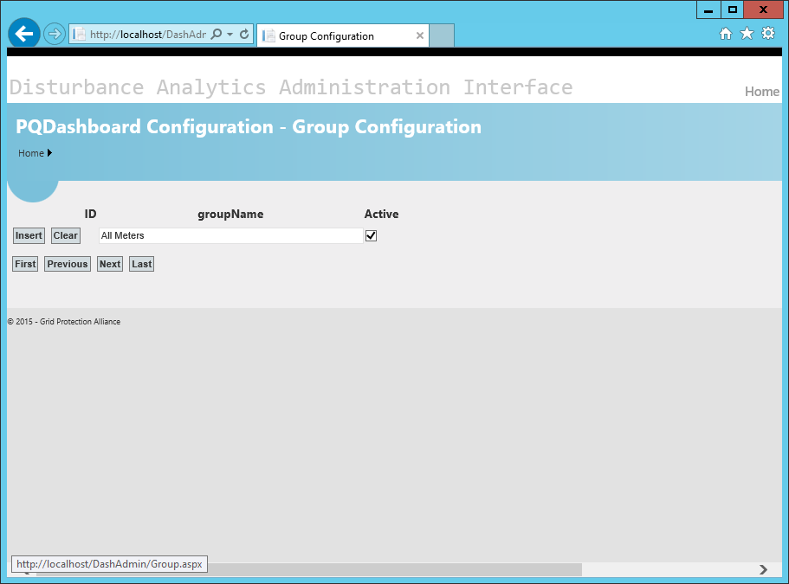

Figure . Enter name, select active, click Insert

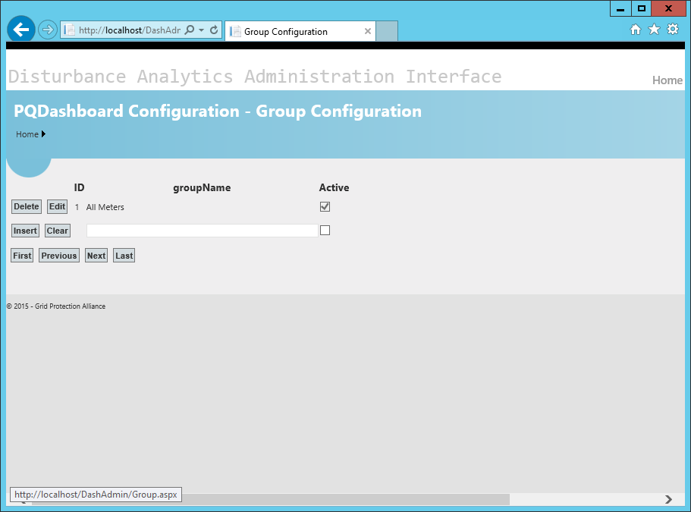

Figure . Edit 'All Meters' group

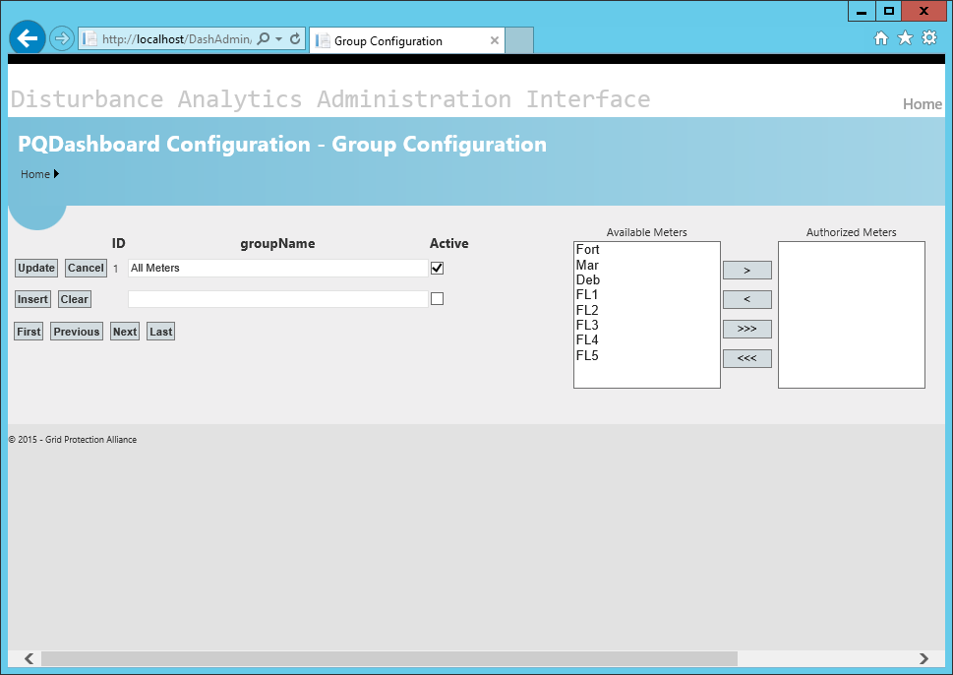

Figure . Available Meters

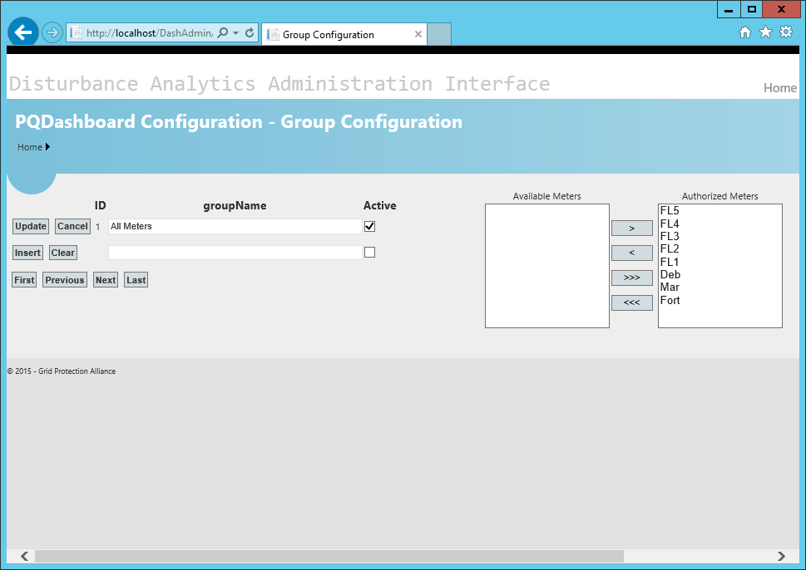

Figure . Move available meters to authorized meters list, and click update

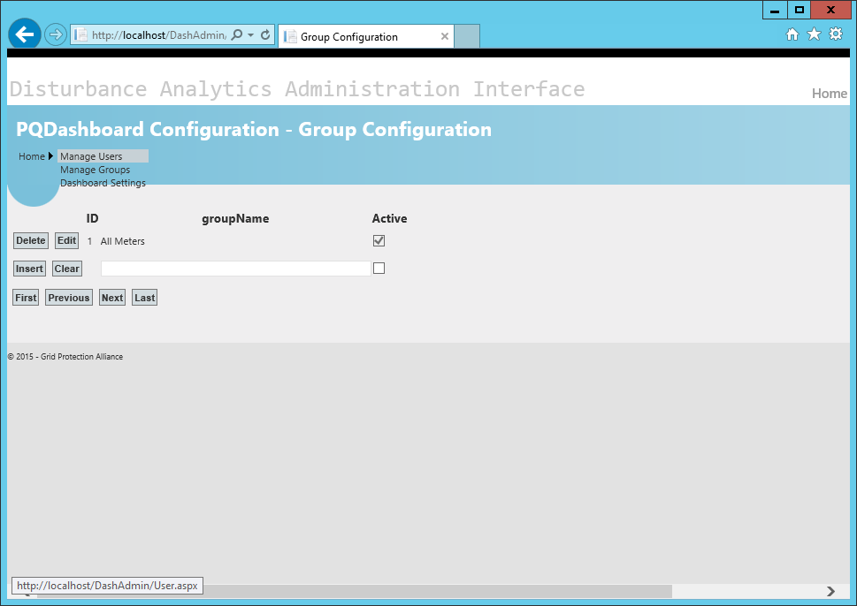

Figure . Manage Users

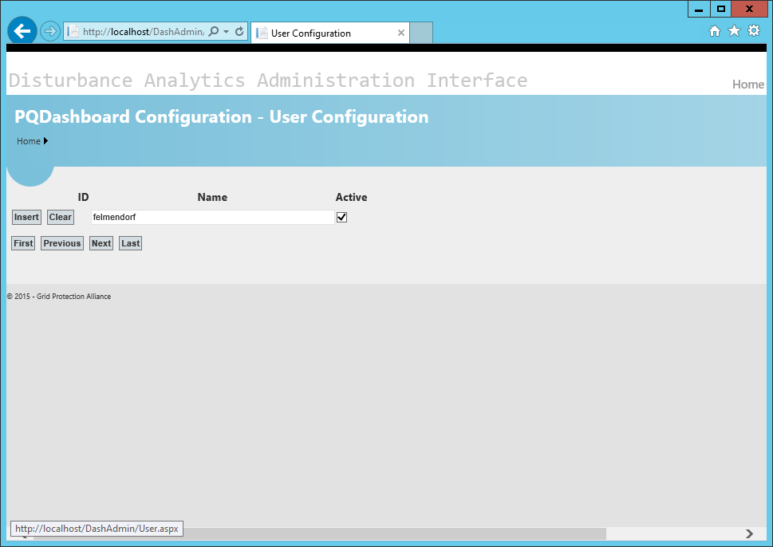

Figure . Enter your Windows user name, check active, click insert

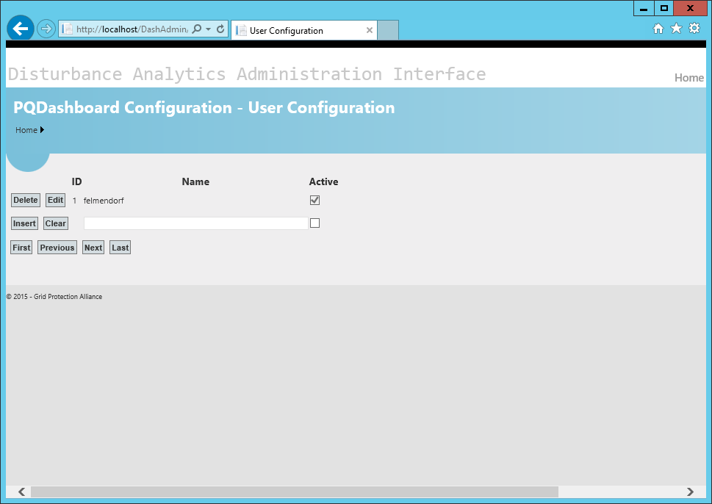

Figure . Click Edit to authorize groups

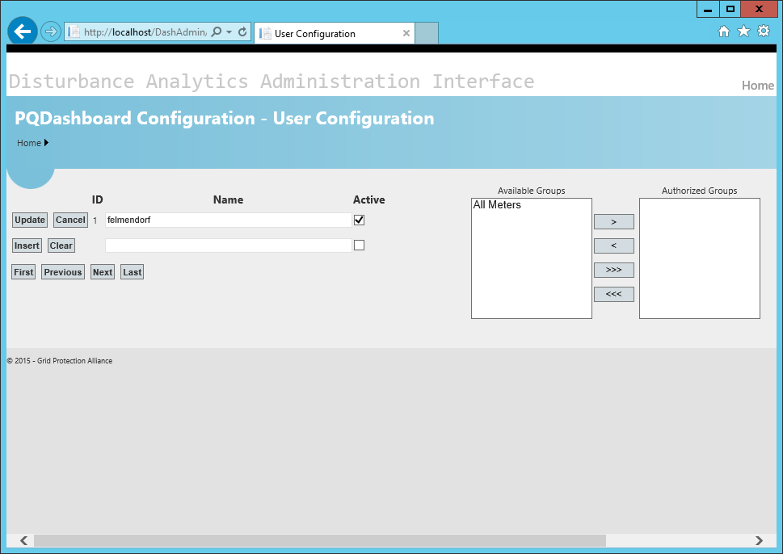

Figure . Available groups

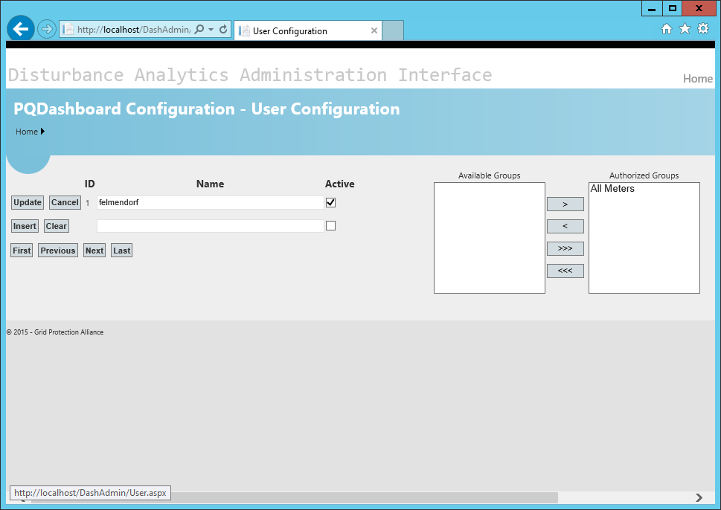

Figure . Move available groups to authorized groups, click update

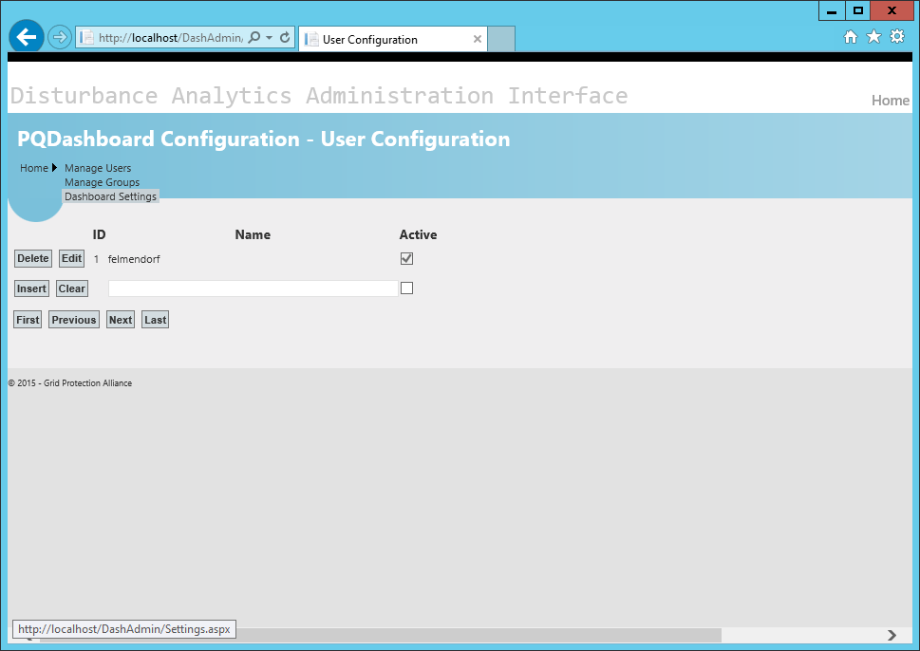

Figure . Click dashboard settings

# operating open pq dashboard

## Locate the PQ Dashboard icon in your programs list



or navigate to <http://localhost/pqdashboard/>

## Components of the Visual Display

The visual display is composed of a context control bar just below the application banner, and three interactive visualization areas. The right half of the display area below the context control bar is the fleet view panel. It provides a comprehensive view of the reporting devices either on a map or in a grid. The left half of the display area below the context control bar is divided into two panels with the overview panel above the detail panel. The general operation of each of the panels remains the same for any type of information displayed. The type of information to be visualized is specified by the tab selected in the context control bar.

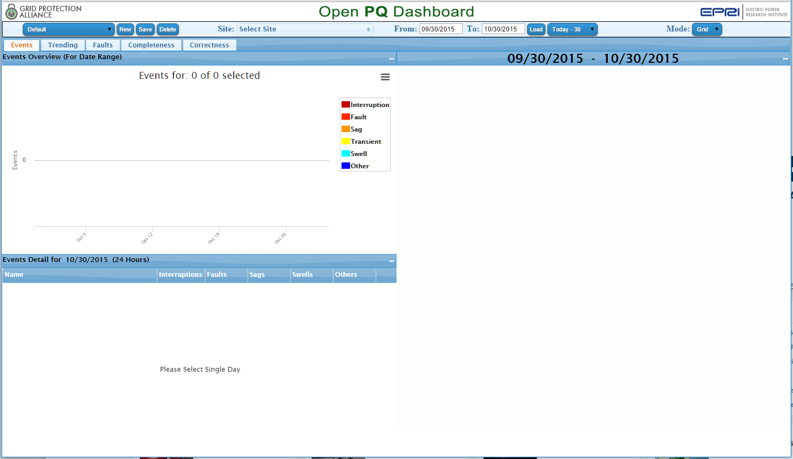

**Context Control Bar**

**Fleet View panel**

**Overview panel**

**Detail panel**

Figure . Open PQ Dashboard: visual display components

## Context Control Bar Elements

The context control bar is composed of two rows of elements.

#### The default context includes all sites, a date range of “Today-30”, a Mode of “Grid”, with the “Events” tab selected.

### Top row elements

#### view controls

The view control elements are named collections of user selected view parameters that have been changed from the default values and saved for future use. Selecting a named view control element immediately loads the specified parameters such as sites, date range, mode, and tab. The Default view control cannot be changed by a user and is always available in the drop down list. The Default view control is loaded when the application is started. A system provided “Last Session” view control is also included that can restore the last session whenever the application is closed and reopened.

#### site selection

The site selection element provides a drop down control to select or deselect sites to be displayed in the visualization panels.

#### date selection

The date selection element provides editable From: and To: date fields to specify arbitrary date ranges. The “Load” button beside the editable date range loads data from the date range specified. A drop down list provides single click data specification for predefined date ranges.

#### mode selection

The mode selection element allows the user to specify a map or grid display in the fleet view panel.

### Second row elements

#### dashboard tabs

#### Dashboard tab elements control the type of information that will be displayed in the visualization panels. For each tab, the information is specific to the sites selected and date range specified. The events tab filters the information such that it is specific to events previously analyzed from input waveform data. The trending tab filters the information such that it is specific to periodically recorded values. The faults tab further limits the events available through the events tab such that information is only presented that relates to the specific event type classified as a fault. The Completeness tab presents information about how much data is received with respect to the data that is expected. The correctness tab presents information about the accuracy of the data received with identification of latched values, non-congruent values, and values that are outside of engineering reasonableness.

## Fleet View Panel

The fleet view panel occupies the right half of the visual display space and presents information regarding site locations in either a grid or map display. Sites may be selected or deselected in either view. A single click will select or deselect an individual site. Control+click allows multiple site select or deselect. The site symbols in the map display and the site squares in the grid display are color coded according to the type of information specified by the dashboard tab selection. An example fleet view panel display would present event count by type for all sites over a specified time range.

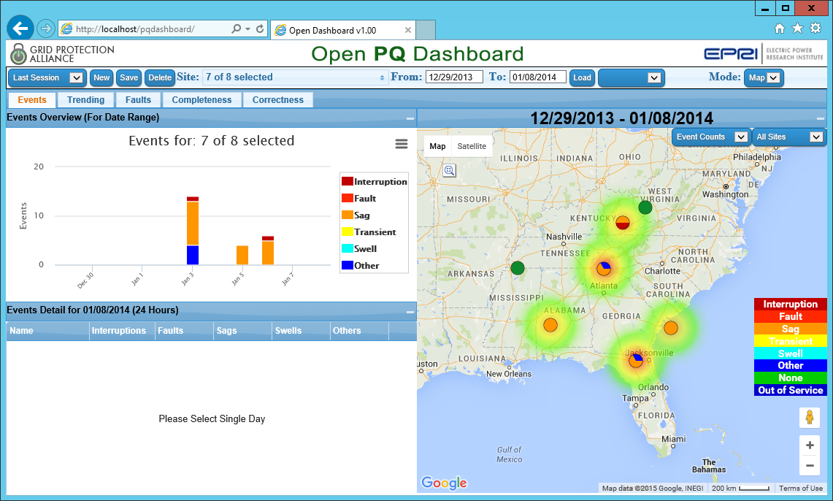

Figure . Fleet view panel example map display

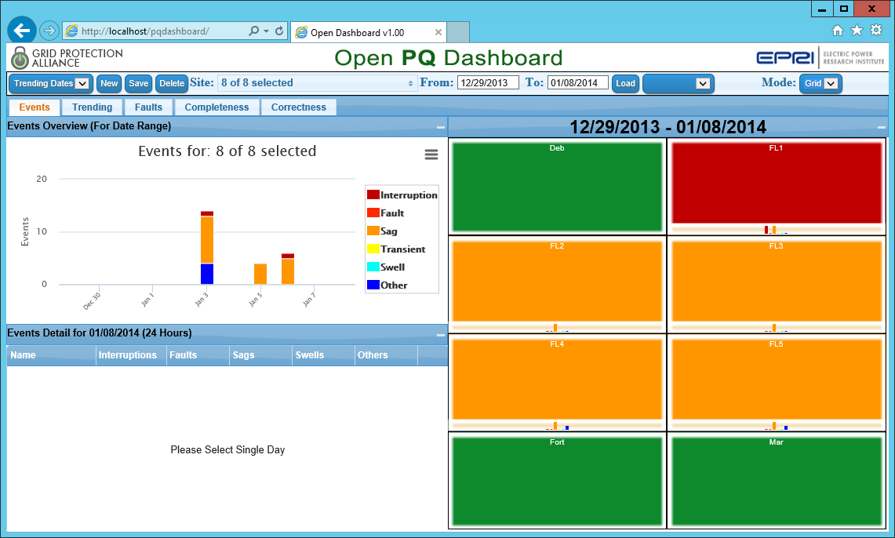

Figure . Fleet view panel example grid display

## Overview Panel

The overview panel occupies the top portion of the left half of the visual display space and presents a summary histogram of the appropriate data as specified through the view control elements and user selections. An example overview panel display is event count by type over a specified time range for the selected sites.



Figure . Overview panel example display

## Detail Panel

The detail panel occupies the bottom portion of the left half of the visual display space and presents detailed information of information for a single day selected by clicking on a bar in the overview panel. An example detail panel display is event detail for a selected day.

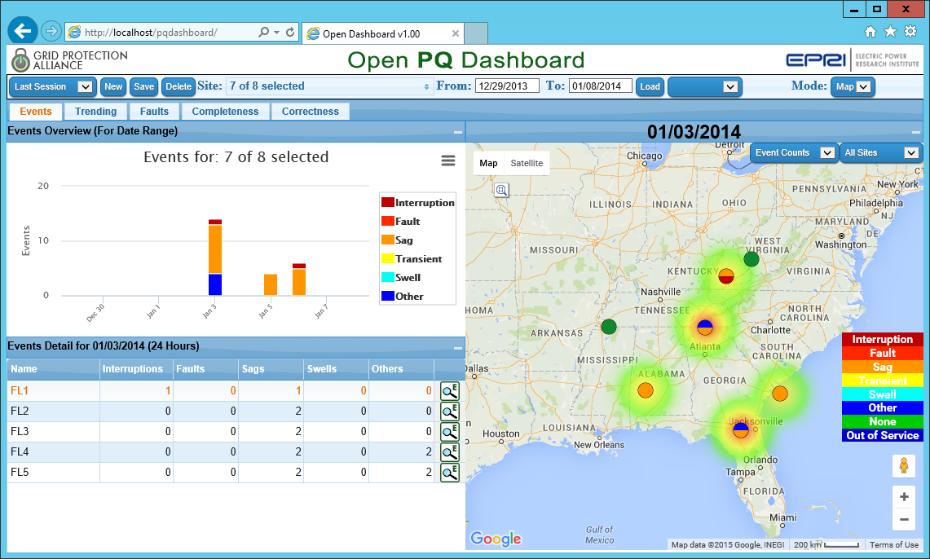

Figure . Detail panel example display

### Events by line for a selected site

#### A list of events for a site ordered by line is displayed by clicking the icon

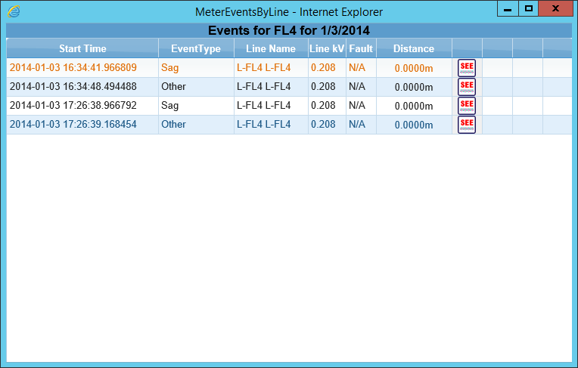

Figure . Example display of events by line for a site

### Waveform display for an event

#### An interactive waveform viewer is available by clicking the icon

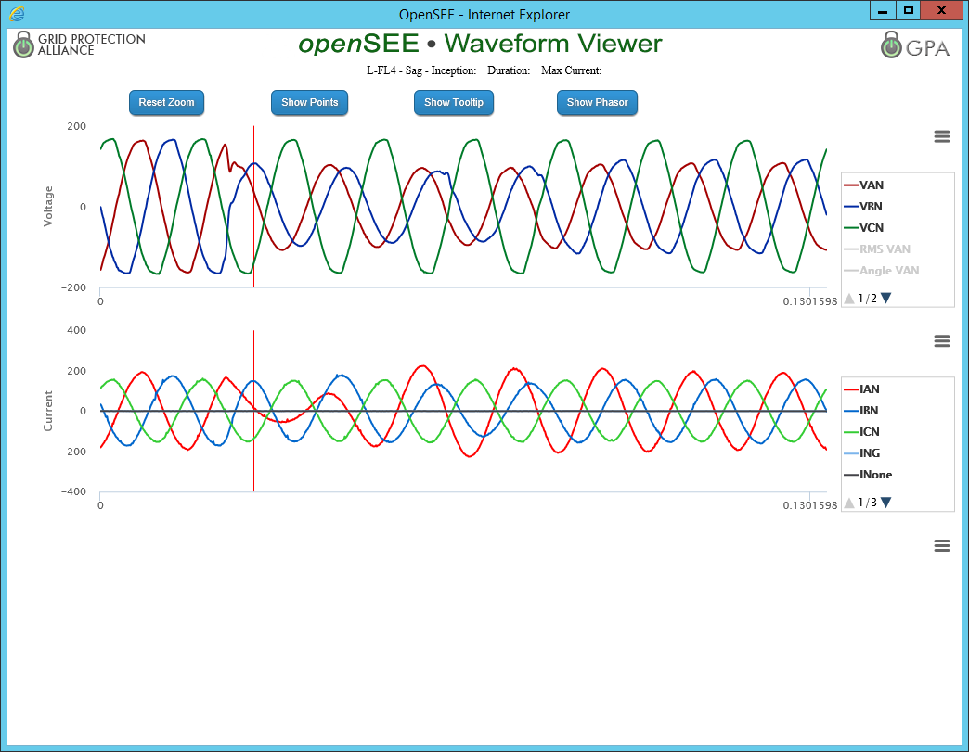

Figure . Example display of waveform viewer

# Enabling PQI integration

## Link Remote Server

In order to enable PQI integration, a link must be created between the openXDA database and the PQI database so that the PQ Dashboard has access to the tables in the PQI Database. Refer to the following links for more information about linked servers and the procedures to manage them.

Linked Servers (Database Engine):  
<https://msdn.microsoft.com/en-us/library/ms188279(v=sql.110).aspx>

sp_addlinkedserver  
<https://msdn.microsoft.com/en-us/library/ms190479(v=sql.110).aspx>

sp_addlinkedsrvlogin  
<https://msdn.microsoft.com/en-us/library/ms189811(v=sql.110).aspx>

## Alter Stored Procedures

Locate the “PQI Integration.sql” file. In this file are some commands to alter stored procedures that exist in the openXDA database so that the PQ Dashboard can query the PQI database tables. You may need to alter these statements to use the identifier for the remote PQI server you set up in the previous step. Execute these statements to update the stored procedures so that the PQ Dashboard can retrieve data from the PQI database.

## Mapping Meters to Facilities

The MeterFacility table in the openXDA database is used to map objects in openXDA’s meter table to objects in PQI’s Facility table. It will be necessary to add mappings for your meters so that you can view the results of the PQI integration in the PQ Dashboard.

# Troubleshooting

## No Data Shown

***Problem:*** The web application loads but does not show any data.

***Possible Solutions:***

1. Make sure date range selected contains valid data. The included sample dataset contains data between 12/29/2013 and 01/08/2014, and 09/03/2014.
2. The SQL Server database must be available to the Open PQ Dashboard. Consult your database administrator.

## Page Unavailable

***Problem:*** Attempts to browse the Open PQ Dashboard web application cause browser to say the page is unavailable.

***Possible Solution:***

1. Make sure the URL is specified correctly. The browser path should be: <http://localhost/pqdashboard/>

|  |  |
| --- | --- |
| © 2015 Electric Power Research Institute (EPRI), Inc. All rights reserved. Electric Power Research Institute, EPRI, and TOGETHER…SHAPING THE FUTURE OF ELECTRICITY are registered service marks of the Electric Power Research Institute, Inc. |  |